Lab 04

Creating Networks in Cisco Packet Tracer

Lab Objectives:

- Design and implement a network topology consisting of two LANs connected through a router
- Configure basic IP addressing and subnet configurations on all network devices
- Enable and configure RIP routing protocol on the router
- Verify network connectivity between the two LANs using appropriate testing commands
- Learn how to create some basic networks in Cisco packet tracer by creating various LANS and then connecting them through routers for the routing.

Background/ Scenario:
In this activity you will build a simple network in Packet Tracer from scratch and then save the network as the packet tracer activity file

Procedure:
Build a Simple Network in the Logical Topology Workspace
- Launch Packet Tracer
Double click on the Packet Tracer icon on your desktop or navigate to the directory that contains the Packet Tracer executable file and launch Packet Tracer. Packet Tracer should open with a blank default Logical topology workspace as shown in the figure.
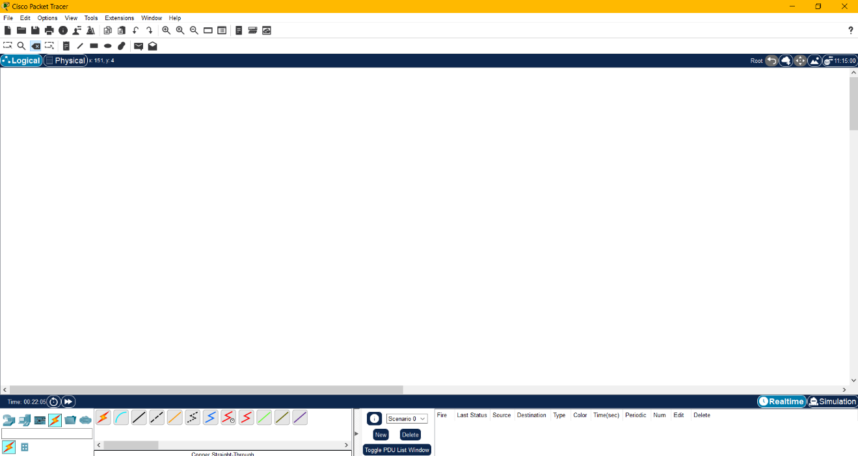

- Build the topology
Add network devices to the workspace.

Using the device selection box, add the network devices to the workspace as shown in the topology diagram.

To place a device onto the workspace, first choose a device type from the Device-Type Selection box. Then, click on the desired device model from the Device-Specific Selection box. Finally, click on a location in the workspace to put your device in that location. If you want to cancel your selection, click the
Cancel icon for that device. Alternatively, you can click and drag a device from the Device-Specific Selection box onto the workspace.
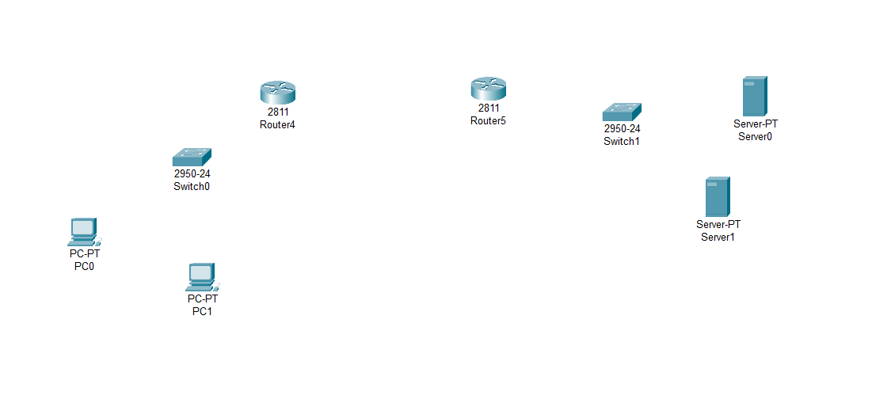

- Change display names of the nework devices
To change the display names of the network devices click on the device icon on the Packet Tracer Logical workspace, then click on the Config tab in the device configuration window. In the Config tab type the new name of the device into the Display Name box as show in the figure.
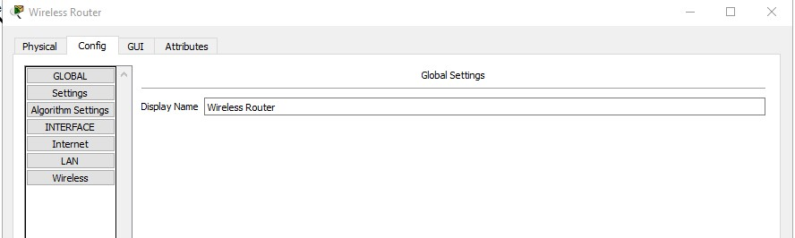

- Add the physical cabling between devices on the workspace
Using the device selection box, add the physical cabling between devices on the workspace as shown in the topology diagram.

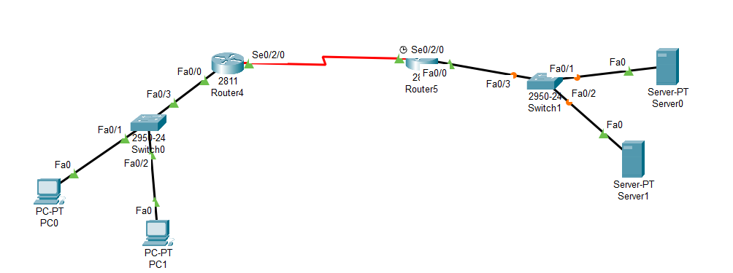
In the figure given above, we have used serial connection between the two routers. For connecting the routers through serial connection we need to add serial module to the router as shown in the figure below
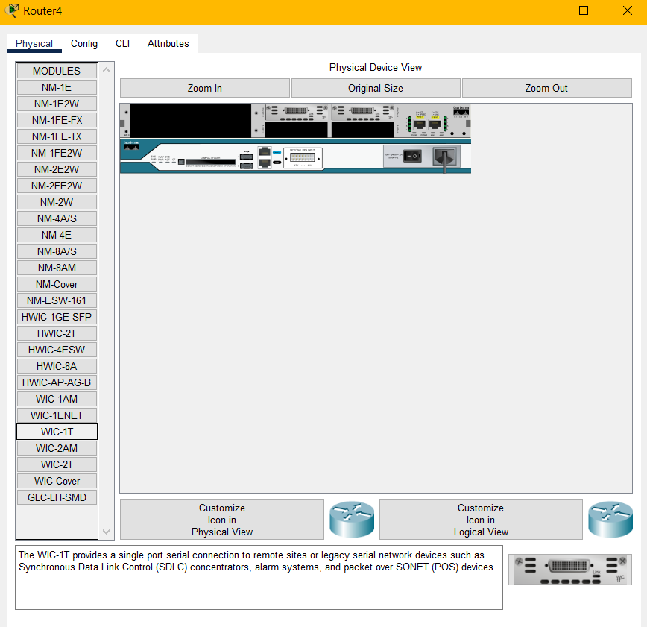

Click on the router and turn off the router. Then from the module section click on “WIC-1T” and drag it to the empty slot of the router and then turn on the router.

- Ports of the routers which are connected through wires should be up.

Click on the router and make the ports up as shown in the figure
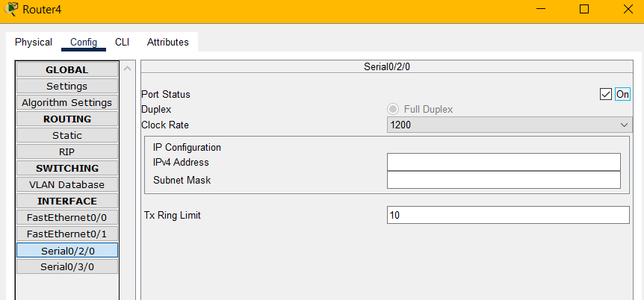

Goto config tab and click on the on checkbox to up the port.
After making the ports up, all the connections are now green as shown in the figure below
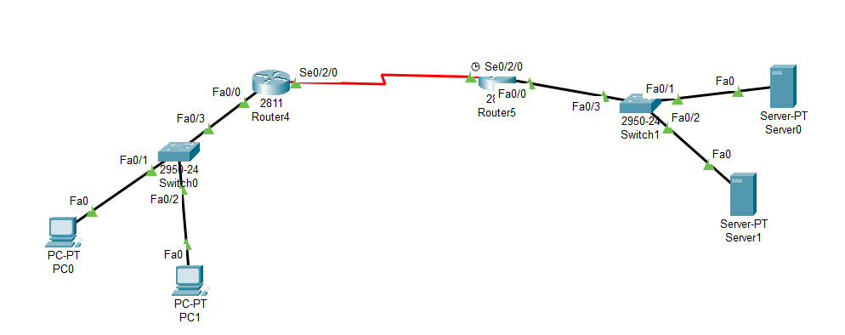
- Now assign ips to the devices

To assign ip to a device, click on the device and goto config tab and click on the interface which is connected to router or other device (here connected interface is FastEthernet0). Assign ip to the appropriate interface as shown in figure

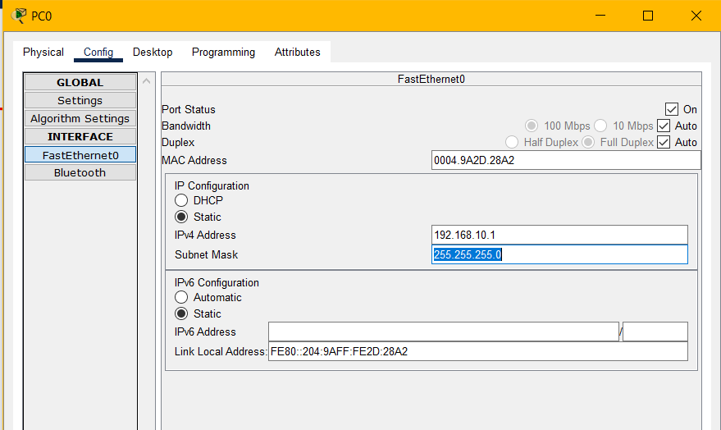

In the same way assign appropriate Ips to other devices as well.

- Assigning IP’s to routers

To assign IP’s to the routers, make sure to assign appropriate default gateways to the connected devices with routers because the interface of the router is a default gateway for a network.

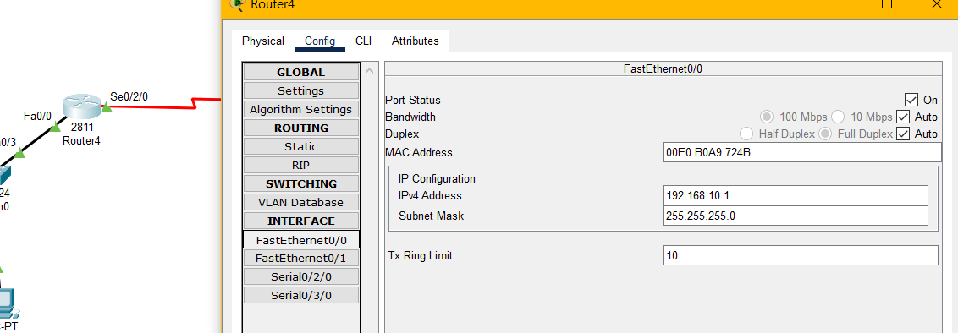

Here in the above screenshot, Fa0/0 interface of the router has an IP 192.168.10.1, which will behave as the default gateway for the network ID: 192.168.10.0. Now also assign this as default gateway to the devices connected with the Fa0/0 interface of the router.

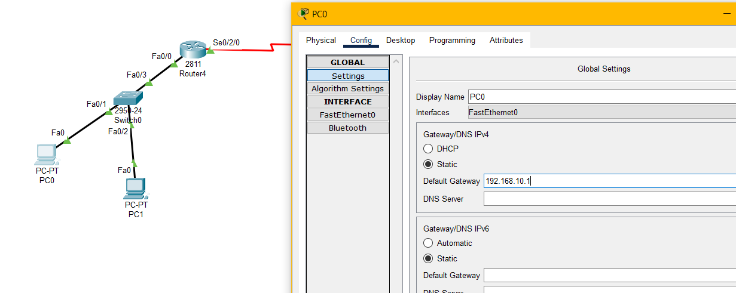

- Now assign IP’s to the serial ports of the router4 and router5.

Here make sure that both of these serial interfaces of router4 and router5 are on the same network by assigning ips to these interfaces of the router4 and router5 in the same network as shown.
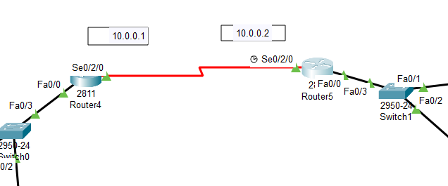

Here 10.0.0.1 ip of interface Se0/2/0 of Router4 and 10.0.0.2 ip of interface Se0/2/0 of router5 are on the same network. So, these routers should be able to communicate with each other.

- Now enable routing on these two routers

We use use RIP routing protocol, which is very easy to configure through the GUI of the routers, as shown in figure
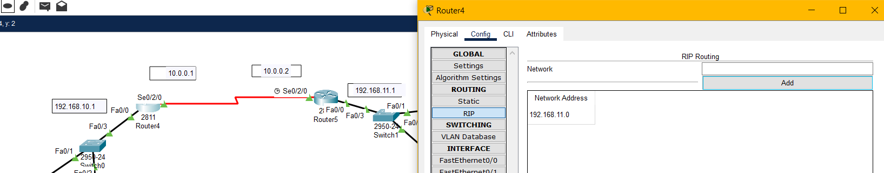
Here in the above screenshot, we have clicked on the router4 and then goto config tab, then click on the RIP. Now, if network 192.168.10.1 wants to communicate with network 192.168.11.1 then we need to add network ID of 192.168.11.0 in the RIP of router4. Similarly, if network 192.168.11.1 wants to communicate with network 192.168.10.1 then we need to add network ID 192.168.10.0 in the RIP of router5. After configuring the RIP protocol these two networks, 192.168.10.1 and 192.168.11.1 should be able to communicate with each other.

- Now test the connectivity of these devices

Click on the end device and goto desktop tab and then click on cmd as shown in the figure
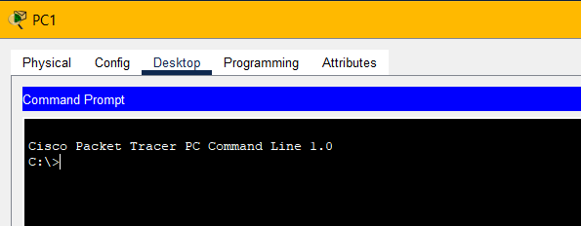

Here in this window, ping the ip of a device which belongs to another network. If that device is pingable then Congratulations your networks can communicate with each other.

TASKS:
- Create 3 LANS, LAN01,LAN02 and LAN03 connected through routers and switches. Each LAN has 4 PCs connected. Use RIP routing protocol to connect these devices. There will be a total of 3 different networks connected with each other. Verify their connectivity. (5)
- Draw and configure the below topology in Cisco Packet tracer by using any IP configurations. Verify the connectivity of this topology. (5)

